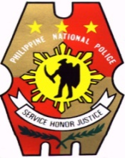Republic of the Philippines

NATIONAL POLICE COMMISSION

**PHILIPPINE NATIONAL POLICE, POLICE REGIONAL OFFICE CALABARZON  
CAVITE POLICE PROVINCIAL OFFICE**

**CARMONA MUNICIPAL POLICE STATION**

J.M. Loyola St., Brgy.Maduya, Carmona, Cavite

**Transfer to BJMP**

|  |  |  |
| --- | --- | --- |
| **NR** | **List of PUPCs** | **Age** |
| 1 | Jason Bataller Roxas | 22 |
| 2 | John Lester Siño De Guzman | 20 |
| 3 | Marcelino Perlas Enriquez | 44 |
| 4 | Randy Caravana Alcanse | 44 |
| 5 | Gregorio Mendoza Leyban | 51 |
| 6 | Nilson Toñacao Campos | 56 |
| 7 | Virgilio Diaros Bayadna | 57 |
| 8 | Rayjohn Umandap Gagarin | 32 |
| 9 | Ronaldo Diotiles Ortiz | 36 |
| 10 | Christoper Kevin Cardona Amoranto | 36 |
| 11 | Sammy Labayo Tiradez | 40 |
| 12 | Wilfredo Mape Loyola | 41 |